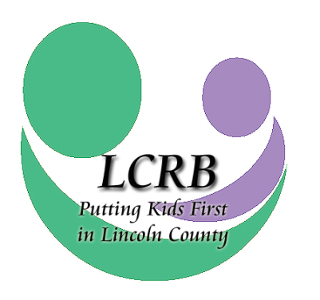
Request for Funding Concept Paper
July 1, 2026 through June 30, 2027
Lincoln County Resource Board

Please make note: The concept paper is to be used only by agencies that have not previously received funding from the Lincoln County Resource Board for the service/program listed below.

The concept paper allows the board to consider a proposed program and its associated costs against the LCRB budget, current LCRB Needs Assessment, and School-based Assessment to validate funding and needs before a full proposal is submitted.

For assistance with this application or for further information, please contact:
Cheri Winchester, Executive Director
director@lincolncountykids.org
Phone: 636-528-2490

CONCEPT PAPER DEADLINE IS Thursday, February 12, 2026, AT 2:00 P.M. Concept papers may be emailed to the LCRB at director@lincolncountykids.org. Please note: Agencies are required to submit one concept paper per program, not per agency. If your agency is requesting funding for more than one program, e.g., counseling and psychiatry, you must submit a concept paper for each proposed program.

PROVIDER NAME:

NAME OF SERVICE/PROGRAM:

Indicate service area(s) for which you are requesting funding ().

AREAS OF SERVICE
 | Temporary Shelter Services |  | Crisis Intervention Services
 | Respite Care Services |  | School-based Prevention Services
 | Services to Unwed Mothers & Teen Parents |  | Transitional Living Programs
 | Outpatient Substance Abuse Treatment Services |  | Home & Community-Based Intervention Services
 | Outpatient Psychiatric Services |  | Individual, Group & Family Counseling Services

Accepted concept papers provide no guarantee of funding. Agencies will be notified by end-of-business Friday, February 27, 2026, if the board requests a comprehensive new program proposal with submitted financials. In this event, the new funding applications would be due to the LCRB office via mail or delivery by 2 p.m. Tuesday, March 31, 2026.

AGENCY PROFILE
Agency Name:
Registered in the State of Missouri as a not-for-profit (501 c3) or governmental agency and classified as being in good standing (Confirm yes in the adjacent cell):
Agency Street Address:
City, State, Zip code
Agency Phone Number:
Agency Website:
Primary Contact Name:
Primary Contact Title:
Email Address:
Contact Phone Number & Ext.:
Contact Cell Phone Number:
Additional Contact Numbers:

Concept Overview

Program Type:

Program Name:

Amount Requested *If asked to submit a full application, the board will consider a marginal variance once unit cost calculations are figured. | Of the requested amount, please delineate the following staff costs: | Number of Youth Served
$ | Direct clinical staff salaries: | #
 | Immediate supervisors’ salaries:
 | Staff fringe benefits:

Provide Brief Program Synopsis, addressing:
- What validated or unmet need does this program address (reference the 2023 LCRB Needs Assessment and local data as relevant)?
- Outline the program’s staff support and credentials, note evidence-informed practices or curriculum the program leverages.
- Address the referral process and how the agency will deliver the program or services (e.g., if school-based, what schools/grade levels are you proposing; if community-based, where will you provide services; do you have local staff in place or will you need to hire staff; etc.).
- What are the program’s clinical outcomes and how will the agency measure outcomes?
- What other funding sources will the agency leverage to support Lincoln County kids and families? (Funding policy calls for at least 25% of funding to come from sources other than funds distributed the Community Children’s Services Fund. These other sources may be public or private, but no more than one-half (1/2) of these other sources may include contributions of goods or services, including materials, commodities, transportation, office space or other types of facilities or personal services.)

