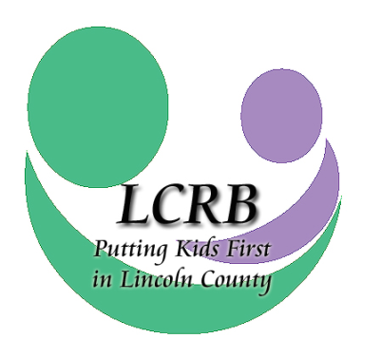
Request for Funding Concept Paper
July 1, 2024 through June 30, 2025
Lincoln County Resource Board

Please make note: The concept paper is to be used only by agencies that have not previously received funding from the Lincoln County Resource Board for the service/program listed below.

The concept paper allows the board to consider a proposed program and its associated costs against the LCRB budget, current LCRB Needs Assessment, and School-based Assessments to validate funding and needs before a full proposal is submitted.

For assistance with this application or for further information, please contact:
Cheri Winchester, Executive Director
director@lincolncountykids.org
Phone: 636-528-2490

CONCEPT PAPER DEADLINE IS Thursday, February 15, 2024, AT 2:00 P.M. Concept papers may be emailed to the LCRB at director@lincolncountykids.org. Please note: Agencies are required to submit one concept paper per program, not per agency. If your agency is requesting funding for more than one program, e.g., counseling and psychiatry, you must submit a concept paper for each proposed program.

PROVIDER NAME: _________________________________________

NAME OF SERVICE/PROGRAM: ___

Indicate service area(s) for which you are requesting funding ().

AREAS OF SERVICE
 | Temporary Shelter Services |  | Crisis Intervention Services
 | Respite Care Services |  | School-based Prevention Services
 | Services to Unwed Mothers & Teen Parents |  | Transitional Living Programs
 | Outpatient Substance Abuse Treatment Services |  | Home & Community-Based Intervention Services
 | Outpatient Psychiatric Services |  | Individual, Group & Family Counseling Services

Accepted concept papers provide no guarantee of funding. Agencies will be notified by end-of-business Wednesday, February 28, 2024, if the board requests a comprehensive new program proposal with submitted financials. In this event, the new funding applications would be due to the LCRB office via mail or delivery by 2 p.m. Monday, April 1, 2024.

AGENCY PROFILE
Agency Name:
Agency Street Address:
City, State, Zip code
Agency Phone Number:
Agency Fax Number:
Agency Website:
Primary Contact Name:
Primary Contact Title:
Email Address:
Contact Phone Number & Ext.:
Contact Cell Phone Number:
Additional Contact Numbers:

Concept Overview

Program Type:

Program Name:

Amount Requested *If asked to submit a full application, the board will consider a marginal variance once unit cost calculations are figured. | Number of Youth Served

Provide Brief Program Synopsis (Limit to 200 words).

