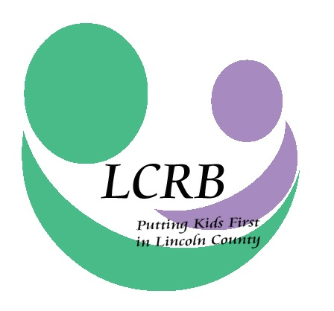
LINCOLN COUNTY RESOURCE BOARD
LINCOLN COUNTY, MISSOURI
Wednesday, August 24, 2016
8:00 a.m.

Lincoln County Health Department
#5 Health Department Drive
Troy, Missouri 63379

AGENDA

- Meeting Called to Order

- Roll Call and Introduction of Guests

- Approval of the July 27, 2016, Meeting Minutes

- Financial Report (Cheri Winchester)

- Correspondence & Announcements

- D.A.R.T. Report (Brittany Pursifull)

- Old Business
- LCRB 2017 Administrative and General Budgets (Cheri Winchester; David Thompson)

- New Business
- MEC Conflict of Interest Ordinance Re-adoption

- Executive Director’s Report
- Written Report
- 2015 LCRB Audit
- Mid-Year Service Reports
- School Assessment Surveys
- Back-to-School Open Houses
- Early Childhood Taskforce
- Legislative Summit/LCRB Anniversary
- CY 2017 Funding Applications

- Committee Reports
  - Finance Committee (David Thompson)
  - Personnel Committee (Margie Beckmann)
  - Selection & Review Committee (Kathy Boessen)

- Comments for the Good

- Adjournment

The next Lincoln County Resource Board meeting will be held on Wednesday, September 28, 2016, at the Lincoln County Health Department, #5 Health Department Drive, Troy, MO at 8:00 a.m.

