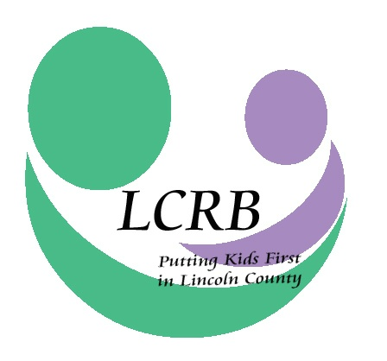
LINCOLN COUNTY RESOURCE BOARD
LINCOLN COUNTY, MISSOURI
Wednesday, May 27, 2020
8:00 a.m.

Zoom Meeting per CDC/COVID-19 Social Distance Recommendations

AGENDA

- Meeting Called to Order

- Roll Call and Introductions

- Approval of the April 22, 2020, Meeting Minutes

- Financial Report (Cheri Winchester)

- Correspondence & Announcements

- D.A.R.T. Report (Michelle Young)

- Old Business
- LCRB Reports
  - 2020 Needs Assessment
  - End-of-School-Year Survey
- LCRB 2020 “Pheeze Kemper Award”

- New Business
- LCRB Mid-Year Report
- LCRB FY 2021 Funding Applications and Concept Papers

- Executive Director’s Report
- Written Report
- All Agency Meeting
- Meetings: LCHD Teen Health; Dr. Amy Salvo, R-III newly appointed Director of Social and Emotional Learning and Supports
- Early Childhood Taskforce: 2020 Shower of Love/Diaper Drive
- 2020 Summit: Bridges Out of Poverty Workshop, Sept. 18
- Missouri Ethics Commission Financial Disclosure Filing, May 1/LCRB Audit
- June Board Meeting

- Committee Reports
  - Finance Committee (Jim Price)
  - Personnel Committee (Kristin Gentry)
  - Selection & Review Committee (Christine Heintzelman)

- Comments for the Good

- Adjournment

Join Zoom Meeting
https://us02web.zoom.us/j/82279393008?pwd=QzRkcnNpUGc2L3BDa3pzSjJ1OVVidz09

Meeting ID: 822 7939 3008
Password: 965304

