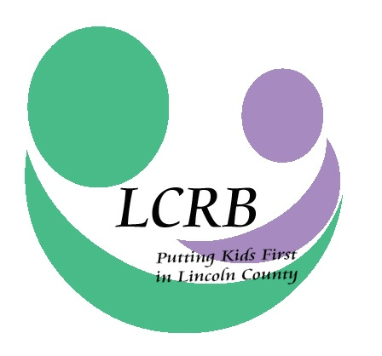
LINCOLN COUNTY RESOURCE BOARD
LINCOLN COUNTY, MISSOURI
Wednesday, November 22, 2017
8:00 a.m.

Lincoln County Health Department
#5 Health Department Drive
Troy, Missouri 63379

AGENDA

- Meeting Called to Order

- Roll Call and Introduction of Guests

- Approval of the October 25, 2017, Meeting Minutes

- Financial Report (Cheri Winchester)

- Correspondence & Announcements

- Provider Brief: Catholic Family Services

- D.A.R.T. Report (Brittany Pursifull)

- Old Business
  - Nominating Committee (Barb Wehde)
  - Needs Assessment
  - Recap: 2017 Legislative Summit & Mobile Outreach Tour

- New Business
- December Meeting Date Change
- Dec. 6 Legislative Outreach Meeting

- Executive Director’s Report
- Written Report
- Billboard Proof
- Early Childhood Taskforce
- Fall Provider Audits
- 2018 Contracts and Clinical Outcomes Agreement

- Committee Reports
  - Finance Committee (David Thompson)
  - Personnel Committee (Margie Beckmann)
  - Selection & Review Committee (Kathy Boessen)

- Comments for the Good

- Adjournment

