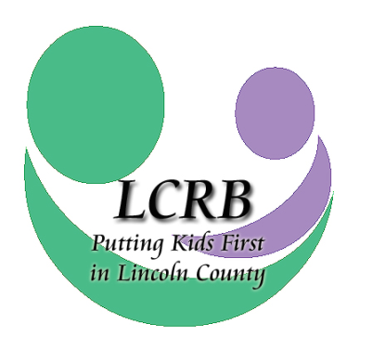
FY 2019 Request for Funding Concept Paper
January 1, 2019—December 31, 2019
Lincoln County Resource Board

Please make note: The concept paper is to be used only by agencies that have not previously received regular funding grants from the Lincoln County Resource Board.

The concept paper allows for the board to consider a proposed program and its associated costs against the projected FY 2019 LCRB budget, current LCRB Needs Assessment and 2018 School Assessments to validate funding and needs before a full proposal is submitted.

For assistance with this application or for further information, please contact:
Cheri Winchester, Executive Director
director@lincolncountykids.org
Phone: 636-528-2490

CONCEPT PAPER DEADLINE IS Friday, JULY 13, 2018, AT 2:00 P.M. Concept papers may be emailed to the LCRB at director@lincolncountykids.org. Please note: Agencies are required to submit one concept paper per program, not per agency. If your agency is requesting funding for more than one program, e.g., counseling and psychiatry, you must submit a concept paper for each proposed program.

NAME OF SERVICE/PROGRAM: _________________________________________________

Indicate service area(s) for which you are requesting funding ().

AREAS OF SERVICE
 | Temporary Shelter Services |  | Crisis Intervention Services
 | Respite Care Services |  | School-based Prevention Services
 | Services to Unwed Mothers & Teen Parents |  | Transitional Living Programs
 | Outpatient Substance Abuse Treatment Services |  | Home & Community-Based Intervention Services
 | Outpatient Psychiatric Services |  | Individual, Group & Family Counseling Services

Agencies will be notified by end-of-business Friday, July 27 if the board requests a complete new program proposal with submitted financials. New funding applications would then be due to the LCRB office via mail or delivery by 2 p.m. Friday, Sept. 14, 2018.

AGENCY PROFILE
Agency Name:
Agency Address: Street
City, State, ZIP CODE
Agency Phone Number:
Agency Fax Number:
Agency Web Site:
Primary Contact: Name
Primary Contact: Title
Email Address:
Contact Phone Number & Ext.
Contact Cell Phone Number:
Additional Contact Numbers:

Concept Overview

Program Type:

Program Name:

Amount Requested *If asked to submit a full application, the board will consider a marginal variance once unit cost calculations are figured. | Number of Youth Served
2019: | Estimate:

Provide Brief Program Synopsis (Limit to 200 words). In the synopsis, include:

- A description of the proposed program, including the problem/unmet need within the community that your program/service aims to address. Please note: the board prefers local statistical data and relevant community information for the problem/unmet need.

- Note how the program activities will be delivered. For example, is the proposed program a school-, home- or community-based program?

- Confirm whether the program employs evidence-based practices and briefly note the practices you plan to employ.

